Data

What is Data
# Source: AI Source: Provided by: [Data Path: Persons Table -> ID Column: 1, Name_En Column: Motasem Essam] -> From: [Chatgpt (GPT‑5 Mini)] on [12/10/2025]
Data is raw facts, figures, or information that can be collected, stored, organized, and analyzed. It can represent numbers, text, measurements, observations, or descriptions about something.

Simple definition
# Source: AI Source: Provided by: [Data Path: Persons Table -> ID Column: 1, Name_En Column: Motasem Essam] -> From: [Chatgpt (GPT‑5 Mini)] on [12/10/2025]
👉 Data = basic information before it is organized or analyzed.

Examples of data
# Source: AI Source: Provided by: [Data Path: Persons Table -> ID Column: 1, Name_En Column: Motasem Essam] -> From: [Chatgpt (GPT‑5 Mini)] on [12/10/2025]
- Numbers: 25, 100, 3.14
- Text: names like "Ahmed", "Sara"
- Dates: 11/03/2026
- Measurements: temperature 30°C, height 170 cm
- Survey answers: Yes / No

Example in real life
# Source: AI Source: Provided by: [Data Path: Persons Table -> ID Column: 1, Name_En Column: Motasem Essam] -> From: [Chatgpt (GPT‑5 Mini)] on [12/10/2025]
Imagine a classroom:
- Student scores: 80, 75, 90, 60 → Data
- Average score calculated from them → Information

Digital data storage units

What Are Digital Data Storage Units?
# Source: AI Source: Provided by: [Data Path: Persons Table -> ID Column: 1, Name_En Column: Motasem Essam] -> From: [Chatgpt (GPT‑5 Mini)] on [12/10/2025]
Digital data storage units are standard measurements used to quantify the amount of data stored in computers and other digital devices.

Simple Explanation
# Source: AI Source: Provided by: [Data Path: Persons Table -> ID Column: 1, Name_En Column: Motasem Essam] -> From: [Chatgpt (GPT‑5 Mini)] on [12/10/2025]
- Computers store information in binary (0s and 1s).
- These 0s and 1s are grouped into bytes, and bytes are grouped into larger units.
- Each higher unit represents more data than the previous.

Common Digital Storage Units
# Source: AI Source: Provided by: [Data Path: Persons Table -> ID Column: 1, Name_En Column: Motasem Essam] -> From: [Chatgpt (GPT‑5 Mini)] on [12/10/2025]
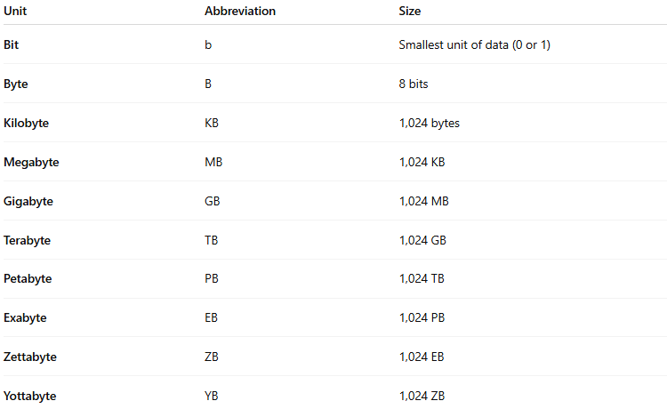
Unit | Abbreviation | Size
Bit | b | Smallest unit of data (0 or 1)
Byte | B | 8 bits
Kilobyte | KB | 1,024 bytes
Megabyte | MB | 1,024 KB
Gigabyte | GB | 1,024 MB
Terabyte | TB | 1,024 GB
Petabyte | PB | 1,024 TB
Exabyte | EB | 1,024 PB
Zettabyte | ZB | 1,024 EB
Yottabyte | YB | 1,024 ZB

Visualization Example
# Source: AI Source: Provided by: [Data Path: Persons Table -> ID Column: 1, Name_En Column: Motasem Essam] -> From: [Chatgpt (GPT‑5 Mini)] on [12/10/2025]
Think of data like water in containers:
- Bit = a single drop
- Byte = a small cup
- Kilobyte = a bottle
- Megabyte = a bucket
- Gigabyte = a tank
- Terabyte = a small lake
- Petabyte/Exabyte = an ocean

Exam-Friendly Definition
# Source: AI Source: Provided by: [Data Path: Persons Table -> ID Column: 1, Name_En Column: Motasem Essam] -> From: [Chatgpt (GPT‑5 Mini)] on [12/10/2025]
Digital data storage units are standard measurements that quantify the amount of digital information, ranging from bits (smallest) to yottabytes (largest).

Data Operations
# Source: AI Source: Provided by: [Data Path: Persons Table -> ID Column: 1, Name_En Column: Motasem Essam] -> From: [Chatgpt (GPT‑5 Mini)] on [12/10/2025]
Data Operations are the set of actions performed on data to collect, store, modify, analyze, and use it in a system.
👉 In simple terms:
Data Operations = all the ways we work with data

Data properties
# Source: AI Source: Provided by: [Data Path: Persons Table -> ID Column: 1, Name_En Column: Motasem Essam] -> From: [Chatgpt (GPT‑5 Mini)] on [12/10/2025]
Data Properties are the characteristics or qualities of data that define how reliable, useful, and suitable it is for use in a system.
👉 In simple terms:
Data Properties = qualities that describe the condition of data

Types of Data
# Source: AI Source: Provided by: [Data Path: Persons Table -> ID Column: 1, Name_En Column: Motasem Essam] -> From: [Chatgpt (GPT‑5 Mini)] on [12/10/2025]
- Quantitative data – numbers (age, salary, temperature)
- Qualitative data – descriptions (color, gender, opinion)

In computing
# Source: AI Source: Provided by: [Data Path: Persons Table -> ID Column: 1, Name_En Column: Motasem Essam] -> From: [Chatgpt (GPT‑5 Mini)] on [12/10/2025]
In computers, data refers to any information that is stored or processed by a system, such as:
- files
- images
- videos
- text
- database records

Short summary
# Source: AI Source: Provided by: [Data Path: Persons Table -> ID Column: 1, Name_En Column: Motasem Essam] -> From: [Chatgpt (GPT‑5 Mini)] on [12/10/2025]
✅ Data = raw facts
✅ Information = processed/organized data

